# Chapter 7

## 1. Assignment 1

Consider the two data files Chap_7_HW_File_2s.csv and Chap_7_HW_File_3s.csv found in the Files for Homework Assignments folder on BlackBoard. Each file consists of four time series, three predictor time series (P1, P2,P3) and a Data time series which may depend on the three predictors. For each file produce a linear regression model P1, P2,P3, P1 and P2, P1 and P3, P2 and P3, and all three. Use the first 90% of the Data to train the models and final 10% as a test case. Plot each model and the original Data. Analyze the models and let R decide which one is the best model.

library(ggplot2)

library(readr)

library(lubridate)

data_2s_df <- read.csv("data/Chap_7_HW_File_2s.csv")

data_3s_df <- read.csv("data/Chap_7_HW_File_3s.csv")

# Convert to correct date format

data_2s_df$Date <- ymd(data_2s_df$Date)

data_3s_df$Date <- mdy(data_3s_df$Date)

# Split the data

split_data <- function(data) {

total_rows <- nrow(data)

split_index <- 1:floor(0.9 * total_rows)

train_df <- data[split_index, ]

test_df <- data[-split_index, ]

list(train_df = train_df, test_df = test_df)

}

split_2s_df <- split_data(data_2s_df)

split_3s_df <- split_data(data_3s_df)

# Function to create models

create_models <- function(train_df) {

models <- list(

P1 = lm(Data ~ P1, data = train_df),

P2 = lm(Data ~ P2, data = train_df),

P3 = lm(Data ~ P3, data = train_df),

P1_P2 = lm(Data ~ P1 + P2, data = train_df),

P1_P3 = lm(Data ~ P1 + P3, data = train_df),

P2_P3 = lm(Data ~ P2 + P3, data = train_df),

P1_P2_P3 = lm(Data ~ P1 + P2 + P3, data = train_df)

)

return(models)

}

models_2s <- create_models(split_2s_df$train_df)

models_3s <- create_models(split_3s_df$train_df)

# Evaluate models

evaluate_models <- function(models, test_df) {

results_df <- data.frame(Model = character(),

RMSE = numeric(),

stringsAsFactors = FALSE)

for (name in names(models)) {

model <- models[[name]]

preds <- predict(model, newdata = test_df)

rmse <- sqrt(mean((test_df$Data - preds)^2))

results_df <- rbind(results_df,

data.frame(Model = name, RMSE = rmse))

}

results_df <- results_df[order(results_df$RMSE), ]

return(results_df)

}

results_2s <- evaluate_models(models_2s, split_2s_df$test_df)

results_3s <- evaluate_models(models_3s, split_3s_df$test_df)

### Let R decide which one is the best model

stepwise_2s <- stepAIC(lm(Data ~ P1 + P2 + P3, data = split_2s_df$train_df),

direction = "both")

stepwise_3s <- stepAIC(lm(Data ~ P1 + P2 + P3, data = split_3s_df$train_df),

direction = "both")

> summary(stepwise_2s)

Call:

lm(formula = Data ~ P1 + P2 + P3, data = split_2s_df$train_df)

Residuals:

Min 1Q Median 3Q Max

-1.01377 -0.49274 -0.01619 0.49471 1.03449

Coefficients:

Estimate Std. Error t value Pr(>|t|)

(Intercept) 0.055097 0.063313 0.87 0.384

P1 1.996318 0.005405 369.37 <2e-16 ***

P2 2.995278 0.005546 540.13 <2e-16 ***

P3 -1.505126 0.005574 -270.05 <2e-16 ***

---

Signif. codes: 0 ‘***’ 0.001 ‘**’ 0.01 ‘*’ 0.05 ‘.’ 0.1 ‘ ’ 1

Residual standard error: 0.5769 on 1310 degrees of freedom

Multiple R-squared: 0.9974, Adjusted R-squared: 0.9974

F-statistic: 1.685e+05 on 3 and 1310 DF, p-value: < 2.2e-16

> summary(stepwise_3s)

Call:

lm(formula = Data ~ P1 + P2, data = split_3s_df$train_df)

Residuals:

Min 1Q Median 3Q Max

-5.0968 -2.9558 -0.0017 2.9568 5.0829

Coefficients:

Estimate Std. Error t value Pr(>|t|)

(Intercept) 5.00630 0.04628 108.18 <2e-16 ***

P1 1.01740 0.04319 23.55 <2e-16 ***

P2 1.01873 0.02179 46.76 <2e-16 ***

---

Signif. codes: 0 ‘***’ 0.001 ‘**’ 0.01 ‘*’ 0.05 ‘.’ 0.1 ‘ ’ 1

Residual standard error: 3.139 on 4599 degrees of freedom

Multiple R-squared: 0.3727, Adjusted R-squared: 0.3724

F-statistic: 1366 on 2 and 4599 DF, p-value: < 2.2e-16

Conclusions:

* stepwise_2s is clearly a much better model since ~99.7% of variance explained (R2) and all predictors (P1, P2, P3) are highly significant.
* For stepwise_3s, the best model is the one R selected (P1, P2), but even that model is weak. The model explains only ~37% of the variance (R2)

### Plots

plot_best_model <- function(best_model, test_df) {

preds <- predict(best_model, newdata = test_df)

plot_df <- data.frame(Actual = test_df$Data, Predicted = preds)

ggplot(plot_df, aes(x = Actual, y = Predicted)) +

geom_line(size=1) +

geom_abline(intercept = 0, slope = 1, linetype = "dashed", color = "blue") +

labs(x = "Test data",

y = "Predicted") +

theme_minimal() +

theme(

axis.title.x = element_text(size = 16, hjust = 0.5),

axis.title.y = element_text(size = 16),

axis.text.x = element_text(size = 14),

axis.text.y = element_text(size = 14),

legend.title = element_text(size = 16),

legend.text = element_text(size = 14)

)

}

plot_best_model(stepwise_2s, split_2s_df$test_df)

plot_best_model(stepwise_3s, split_3s_df$test_df)

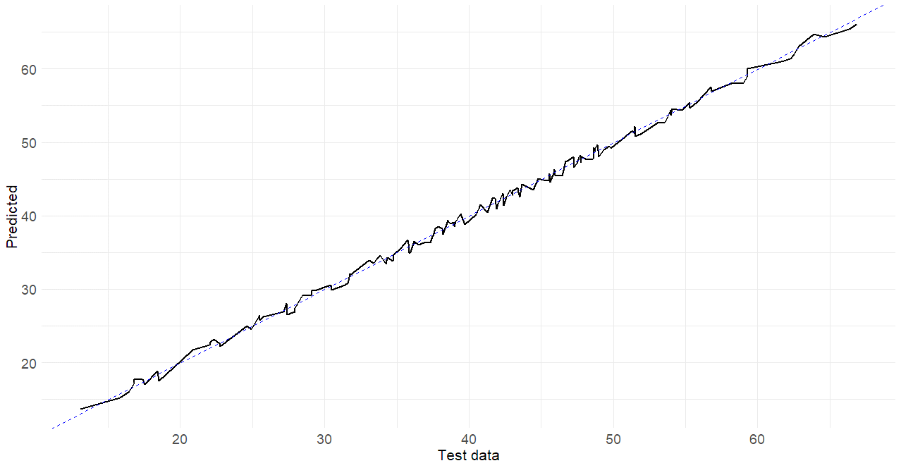

Figure 1: Test data vs predicted (2s file)

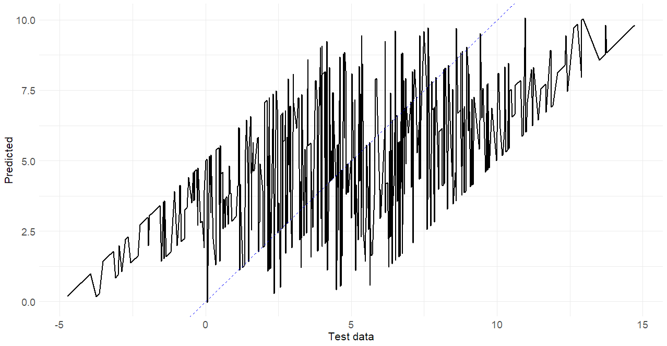

Figure 2: Test data vs predicted (3s file)

Conclusions: stepwise_2s is clearly a much better model with close prediction with the test data

## 2. Assignment 2

The annual population of Afghanistan is available in the global_economy data set.

### a. Plot the data and comment on its features.

afghanistan_population <- global_economy %>%

filter(Country == "Afghanistan")

afghanistan_population %>%

tsibble(index = Year)%>%

ggplot(aes(x = Year, y = Population)) +

geom_line(size=1) +

labs(x = "Year",

y = "Population") +

theme_minimal() +

theme(

axis.title.x = element_text(size = 16, hjust = 0.5),

axis.title.y = element_text(size = 16),

axis.text.x = element_text(size = 14),

axis.text.y = element_text(size = 14),

legend.title = element_text(size = 16),

legend.text = element_text(size = 14)

)

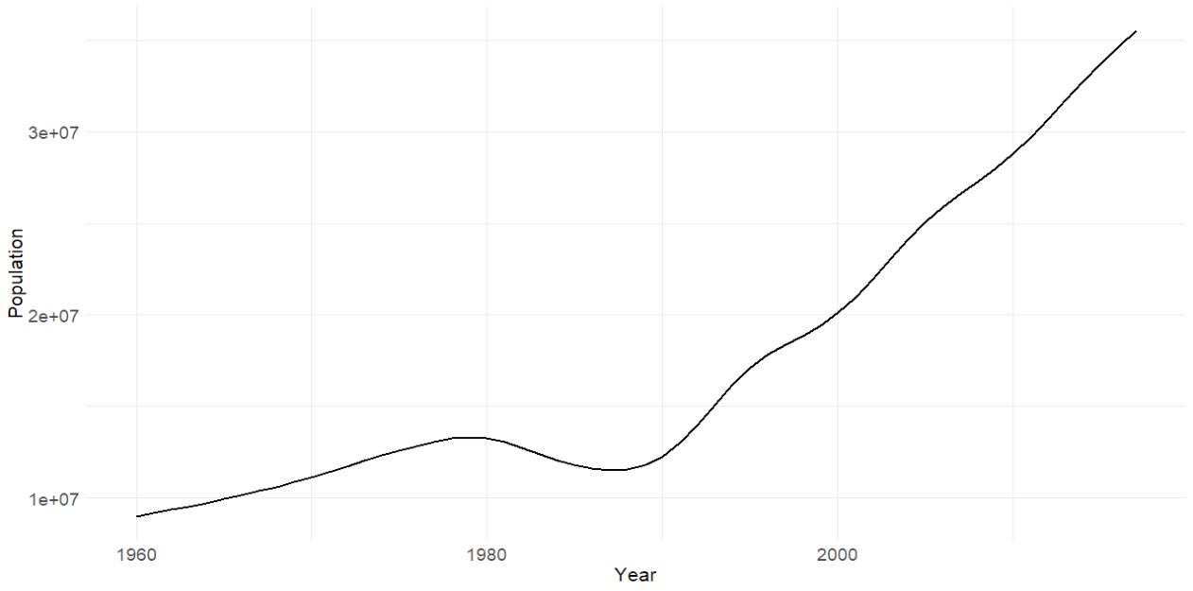

Figure 3: Time Series: Afghanistan Population vs Year

The population grew slowly from 1960 to 1980, then began to decline until 1990, after which it increased rapidly.

## b. Fit a linear trend model and compare this to a piecewise linear trend model with knots at 1980 and 1989.

### Linear trend model

linear_trend_model <- afghanistan_population %>%

model(Linear = TSLM(Population ~ trend()))

linear_trend_model %>% report()

Series: Population

Model: TSLM

Residuals:

Min 1Q Median 3Q Max

-5794518 -2582559 744761 2259222 6036280

Coefficients:

Estimate Std. Error t value Pr(>|t|)

(Intercept) 4798904 848259 5.657 5.45e-07 ***

trend() 425774 25008 17.025 < 2e-16 ***

---

Signif. codes: 0 ‘***’ 0.001 ‘**’ 0.01 ‘*’ 0.05 ‘.’ 0.1 ‘ ’ 1

Residual standard error: 3188000 on 56 degrees of freedom

Multiple R-squared: 0.8381, Adjusted R-squared: 0.8352

F-statistic: 289.9 on 1 and 56 DF, p-value: < 2.22e-16

### Piecewise linear trend model

piecewise_linear_trend_model <- afghanistan_population %>%

model(Piecewise_Linear = TSLM(Population ~ trend(knots = c(1980, 1989))))

piecewise_linear_trend_model %>% report()

Series: Population

Model: TSLM

Residuals:

Min 1Q Median 3Q Max

-577590 -174198 -16784 187226 679947

Coefficients:

Estimate Std. Error t value Pr(>|t|)

(Intercept) 8697573 131122 66.33 <2e-16 ***

trend(knots = c(1980, 1989))trend 224372 9623 23.32 <2e-16 ***

trend(knots = c(1980, 1989))trend_21 -456804 24498 -18.65 <2e-16 ***

trend(knots = c(1980, 1989))trend_30 1082782 21418 50.55 <2e-16 ***

---

Signif. codes: 0 ‘***’ 0.001 ‘**’ 0.01 ‘*’ 0.05 ‘.’ 0.1 ‘ ’ 1

Residual standard error: 300900 on 54 degrees of freedom

Multiple R-squared: 0.9986, Adjusted R-squared: 0.9985

F-statistic: 1.293e+04 on 3 and 54 DF, p-value: < 2.22e-16

### Compare the models visually

fit <- afghanistan_population %>%

model(

Linear = TSLM(Population ~ trend()),

Piecewise_Linear = TSLM(Population ~ trend(knots = c(1980, 1989)))

)

augment(fit) %>%

autoplot(.fitted) +

geom_line(aes(y = Population), colour = "black", size=1) +

labs(x = "Year",

y = "Population") +

theme_minimal() +

theme(

axis.title.x = element_text(size = 16, hjust = 0.5),

axis.title.y = element_text(size = 16),

axis.text.x = element_text(size = 14),

axis.text.y = element_text(size = 14),

legend.title = element_text(size = 16),

legend.text = element_text(size = 14)

)

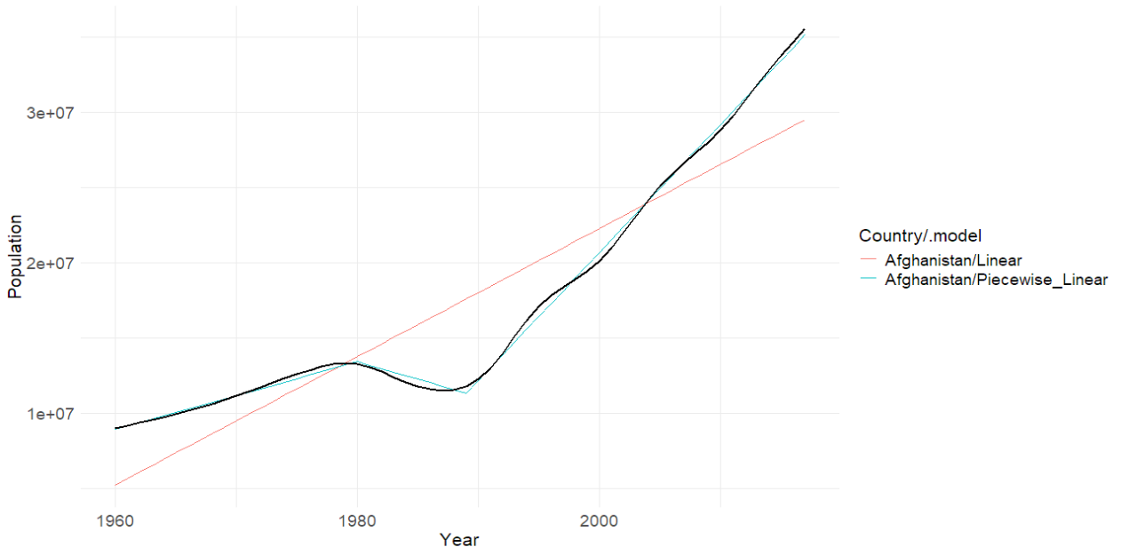

Figure 4: Linear trend model vs Piecewise linear trend model

Based on the graph and from the reports, the piecewise linear model explains 99.86% of the variance in the data, much higher than the 83.81% explained by the simple linear model. Its residual error is also about 90% lower, indicating much better accuracy.

### c. Generate forecasts from these two models for the five years after the end of the data, and comment on the results.

next_5_years_forecast <- fit %>% forecast(h = "5 years")

autoplot(next_5_years_forecast) +

autolayer(afghanistan_population, Population) +

theme_minimal() +

theme(

axis.title.x = element_text(size = 16, hjust = 0.5),

axis.title.y = element_text(size = 16),

axis.text.x = element_text(size = 14),

axis.text.y = element_text(size = 14),

legend.title = element_text(size = 16),

legend.text = element_text(size = 14)

)

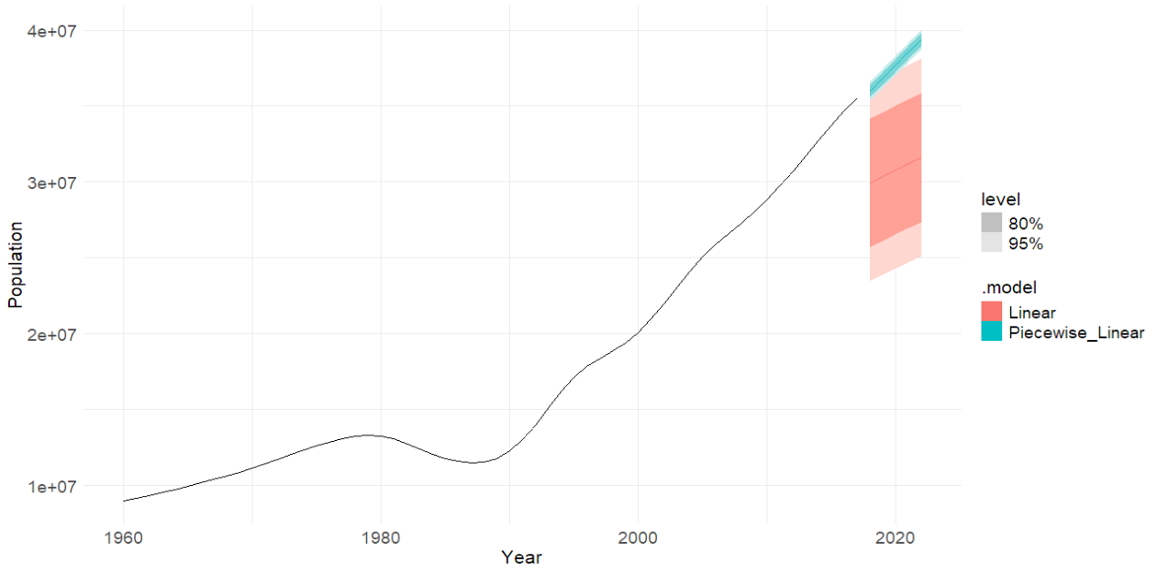

Figure 5: Forecasts from two models

The linear model appears inadequate, as it produces excessively wide prediction intervals and systematically underestimates future values.

In contrast, the piecewise linear model provides a better fit to the data. However, its prediction intervals are likely too narrow, reflecting overconfidence in the model's assumptions.